***Discovery May Help Decipher Ancient Inca String Code***

*New clues to an old mystery about Inca writing aren't etched in stone. They're tied in knots.*

*BY* [***DANIEL STONE***](https://www.nationalgeographic.com/contributors/s/daniel-stone.html)

*PUBLISHED APRIL 19, 2017*

***A DISCOVERY MADE*** in a remote mountain village high in the Peruvian Andes suggests that the ancient Inca used accounting devices made of knotted, colored strings for more than accounting.

The devices, called khipus (pronounced kee-poos), used combinations of knots to represent numbers and were used to inventory stores of corn, beans, and other provisions. Spanish accounts from colonial times claim that Inca khipus also encoded history, biographies, and letters, but researchers have yet to decipher any non-numerical meaning in the cords and knots.

Now a pair of khipus protected by Andean elders since colonial times may offer fresh clues for understanding how more elaborate versions of the devices could have stored and relayed information.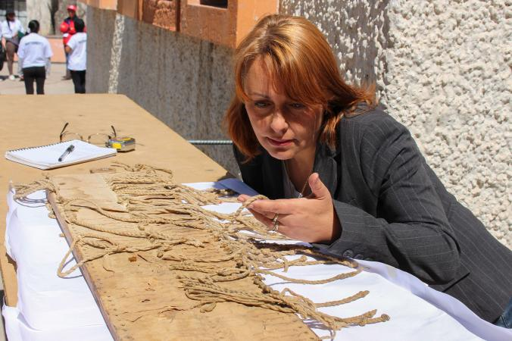

*Anthropologist Sabine Hyland studies a khipu board, a colonial-era invention that incorporated earlier Inca technology.*

*PHOTOGRAPH BY CHRISTINE LEE, NAT GEO IMAGE COLLECTION*

“What we found is a series of complex color combinations between the cords,” says [Sabine Hyland](http://sabinehyland.com/), professor of anthropology at St. Andrews University in Scotland and a National Geographic Explorer. “The cords have 14 different colors that allow for 95 unique cord patterns. That number is within the range of symbols in logosyllabic writing systems.”

Hyland theorizes that specific combinations of colored strings and knots may have represented syllables or words. Her analysis of the khipus appears in the journal [*Current Anthropology*](http://www.journals.uchicago.edu/doi/full/10.1086/691682).

***Secret Messages***

Hyland made her discovery in the Andean village of San Juan de Collata when village elders invited her to study two khipus the community has carefully preserved for generations. Village leaders said the khipus were “narrative epistles about warfare created by local chiefs,” Hyland reports.

The khipus were stored in a wooden box that until recently was kept secret from outsiders. In addition to the khipus, the box contained dozens of letters dating to the 17th and 18th centuries. Most of the documents are official correspondence between village leaders and the Spanish colonial government concerning land rights.

Spanish chroniclers noted that Inca runners carried khipus as letters, and evidence suggests that the Inca composed khipu letters to ensure secrecy during rebellions against the Spanish, according to Hyland.

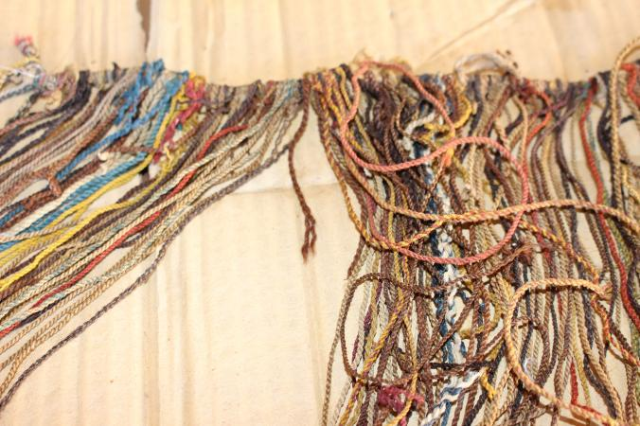

*A khipu from the Andean village of San Juan de Collata may contain information about the village's history.*

*PHOTOGRAPH BY SABINE HYLAND, NAT GEO IMAGE COLLECTION*

“The Collata khipus are the first khipus ever reliably identified as narrative epistles by the descendants of their creators,” Hyland writes in her analysis. She notes that they are larger and more complex than typical accounting versions, and unlike most khipus, which were made of cotton, the Collata khipus were made from the hair and fibers of Andean animals, including vicuna, alpaca, guanaco, llama, deer, and the rodent vizcacha.

Animal fibers accept and retain dyes better than cotton, and so they provided a more suitable medium for khipus that used color as well as knots to store and convey information.

In fact several variables—including color, fiber type, even the direction of the cords’ weave or ply—encode information, villagers told Hyland, so that reading the khipus requires touch as well as sight.

Hyland cites a Spanish chronicler who claimed that khipus made from animal fiber “exhibited a diversity of vivid colors and could record historical narratives with the same ease as European books.”

***The Big Question***

The Collata khipus are believed to date from the mid-18th century, more than 200 years after Spanish colonizers first arrived in 1532. This raises the question whether they are a relatively recent innovation, spurred on by contact with alphabetic writing, or whether they bear a close similarity to earlier narrative khipus.

“These findings are historically very interesting, but time is a big problem,” says Harvard anthropologist [Gary Urton](https://anthropology.fas.harvard.edu/people/gary-urton). “Whether or not we can take these findings and project them into the past, that remains the big question.”

A few years ago, Urton and Peruvian archaeologist [Alejandro Chu](http://pitt.academia.edu/AlejandroChu) discovered a trove of khipus in what may have been a khipu workshop or possibly a repository of Inca records.

***THREADS THAT SPEAK: UNRAVELING THE MYSTERIES OF THE INCA***

Deciphering patterns hidden within the devices may eventually become the work of computers, Urton says. He and his Harvard colleagues maintain a digital repository called the [Khipu Database](http://khipukamayuq.fas.harvard.edu/) that categorizes images, descriptions, and comparisons of more than 500 of the artifacts.

The Inca at their height may have made thousands of khipus, perhaps even hundreds of thousands. But archaeologists suspect that natural deterioration and European colonizers destroyed most of the devices. Fewer than 1,000 are known to exist today.

Hyland plans to return to Peru in July to resume her research. Last summer, on her last day of fieldwork, she met an elderly woman who said she remembered using khipus as a young girl. But before Hyland could ask more questions, the woman darted away to tend to her livestock.

Hyland’s goal is not only to solve a historical mystery, she says, but also to bring to light the “incredible intellectual accomplishments of Native American people.”